Recent Campaigns and Initiives by Surat Municipal Corporation (SMC)
- Green Vehicle Policy 2025
In September 2025, Surat Municipal Corporation launched the Green Vehicle Policy 2025, marking India’s first municipal-level policy dedicated to large-scale adoption of electric and alternative-fuel vehicles. The policy aims to achieve 50 percent electric vehicle adoption by the year 2030. To encourage citizens and businesses, SMC offers financial incentives such as subsidies of up to ₹1 lakh on electric vehicle purchases, five-year vehicle tax exemptions, reduced registration fees, and priority support for charging infrastructure. More than 460 public EV charging stations are planned across the city through Public-Private Partnerships, ensuring easy accessibility. Dedicated monitoring committees comprising technical experts, municipal officials, and citizen representatives were formed to oversee implementation. This policy significantly contributes to reducing carbon emissions, improving air quality, and establishing Surat as a national leader in sustainable urban transport.
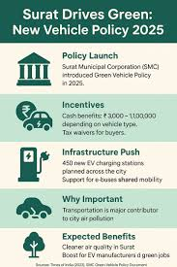
- EcoKranti Plastic Elimination Campaign
In late 2025, SMC partnered with The Art of Living’s EcoKranti initiative to address the growing problem of single-use plastic pollution. Under this campaign, eco-friendly alternatives worth more than ₹10 lakh were distributed across over 50 locations in the city. The initiative focused on replacing plastic bags, cutlery, and packaging with biodegradable products. Awareness programmes, street campaigns, and interactions with shopkeepers and industries were conducted to promote long-term behavioural change. The campaign encouraged citizens to adopt sustainable daily habits and supported Surat’s vision of becoming a plastic-free city.
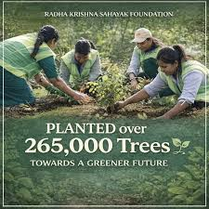
- Mentor City Initiative – Swachh Sheher Jodi
Surat was selected as a Mentor City under the Swachh Sheher Jodi programme of the Swachh Bharat Mission. As part of this responsibility, Surat mentored four cities—Palitana, Savarkundla, Talaja, and Vallabhipur—over a period of 100 days. The mentoring process included sharing best practices related to waste segregation at source, solid and liquid waste management systems, sanitation worker welfare, citizen participation, and effective communication strategies. Surat’s technical expertise and administrative guidance helped these cities improve their cleanliness rankings and service delivery standards.
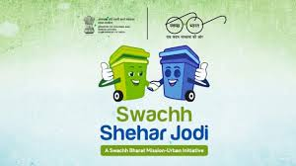
- National Water Awards and Water Conservation Campaign
Surat received the Best Urban Local Body Award at the 5th National Water Awards for its outstanding performance in water conservation and management. Key initiatives included the establishment of tertiary wastewater treatment plants, reuse of treated water for industrial purposes, and extensive groundwater recharge projects. By supplying treated water to industries, the city saves approximately 115 MLD of freshwater. Large-scale tree plantation drives and rainwater harvesting systems further strengthened the city’s water security. These initiatives positioned Surat as a role model for sustainable water management in urban India.
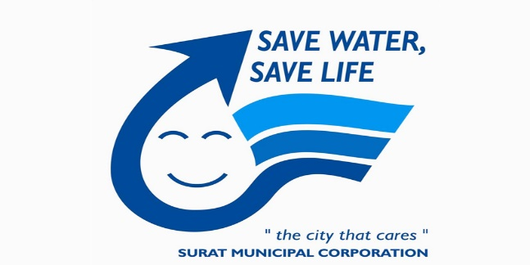
- Jal Sanchay Jan Bhagidari Abhiyan
Under the national Jal Sanchay Jan Bhagidari Abhiyan, Surat district received top-level recognition for its integrated water conservation efforts. The success of the campaign was driven by infrastructure upgrades, efficient planning, restoration of water bodies, rainwater harvesting, and strong community involvement. Citizen participation played a crucial role in reducing water wastage and dependence on external water sources, ensuring long-term water sustainability for the city.
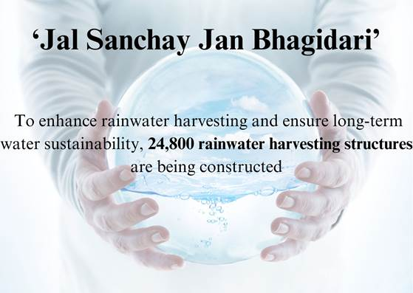
6.Karuna Abhiyan 2026 – Bird and Animal Welfare
During the Uttarayan festival in January 2026, Surat Municipal Corporation actively supported Karuna Abhiyan, a city-wide bird and animal welfare campaign aimed at protecting birds injured due to kite flying. The campaign lasted for five days and was conducted in collaboration with animal welfare NGOs, veterinary doctors, volunteers, and social organisations. Temporary rescue centres were set up across different zones of the city, along with emergency helplines for reporting injured birds and animals. A total of 1,841 injured birds were rescued, treated, and rehabilitated during the campaign. Awareness programmes were conducted in residential areas and schools to promote the use of safe kite strings and responsible celebration of festivals. The initiative successfully balanced cultural traditions with compassion and environmental responsibility.

- Sewage Treatment to Revenue Conversion Initiative
Surat Municipal Corporation introduced an innovative model that converts wastewater management into a sustainable revenue-generating system. Treated sewage water from advanced sewage treatment plants is supplied to industries for non-potable purposes such as cooling, processing, and cleaning. This initiative currently generates approximately ₹140 crore in annual revenue for SMC. By reusing treated water, the city significantly reduces its dependence on freshwater sources such as rivers and groundwater. Surat plans to increase wastewater reuse from the current 33 percent to 70 percent by 2030 and aims for 100 percent reuse by 2035. This initiative strengthens environmental sustainability while improving the financial health of the municipal corporation.
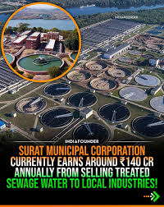
- Large-Scale Development Project Inaugurations
In mid-2025, Surat Municipal Corporation inaugurated development projects worth ₹232 crore, reflecting its commitment to holistic urban development. These projects included the construction of new sewage pipelines that improved sanitation services for nearly 60,000 residents, development of a biodiversity park to promote environmental awareness, construction of modern municipal school buildings, and upgradation of hospital management information systems. The improvements in healthcare infrastructure enhanced patient record management and service efficiency. Together, these projects contributed to better public health, education quality, environmental conservation, and overall urban infrastructure.
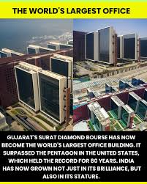
- Property Safety Compliance Campaign
To enhance public safety, Surat Municipal Corporation carried out extensive safety audits of 7,642 high-footfall properties, including schools, hospitals, shopping complexes, markets, theatres, and event venues. The audits focused on fire safety systems, electrical safety, emergency exits, structural stability, and disaster preparedness. Property owners were instructed to follow Standard Operating Procedures and implement corrective measures wherever gaps were identified. Training and awareness sessions were also conducted to ensure compliance with national safety guidelines. This campaign significantly reduced risks in public spaces and strengthened the city’s emergency preparedness framework.
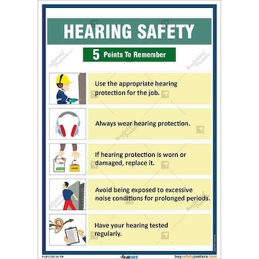
- Swachh Vayu Survekshan – Air Quality Drive
Surat secured first rank in Swachh Vayu Survekshan 2024 and earned recognition as a National Clean Air City due to its sustained efforts in air pollution control. The municipal corporation implemented measures such as mechanised road sweeping to reduce dust, electric vehicle-based garbage collection, strict control on construction dust, and increased green cover through tree plantation. Public transport electrification and promotion of non-motorised transport further contributed to emission reduction. Continuous air quality monitoring and public awareness campaigns helped maintain long-term improvements in urban air quality.
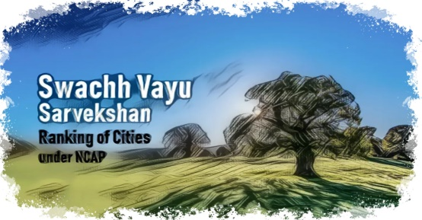

11. Public Cleanliness and Behavioural Change Campaigns
Surat Municipal Corporation continues long-term behavioural change campaigns to maintain high standards of cleanliness across the city. These campaigns focus on preventing public spitting, littering, open dumping of waste, and unhygienic practices. Enforcement actions such as spot fines are combined with awareness programmes, school education initiatives, street messaging, and community participation drives. Regular monitoring and citizen involvement have helped instil a strong sense of civic responsibility, making cleanliness a shared social value in Surat.
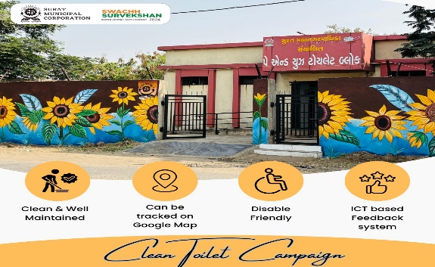
12. Smart Education and Technology Integration
Surat Municipal Corporation became the first municipal corporation in India to introduce advanced technologies such as Artificial Intelligence, Robotics, Drone Technology, and AR and VR-based learning in municipal schools. The initiative was implemented across multiple Suman High Schools with the objective of providing students with future-ready skills. Special labs, trained instructors, and modern learning modules were introduced to enhance practical learning. This programme bridges the digital divide, improves learning outcomes, and prepares students from municipal schools for careers in science, technology, and innovation.
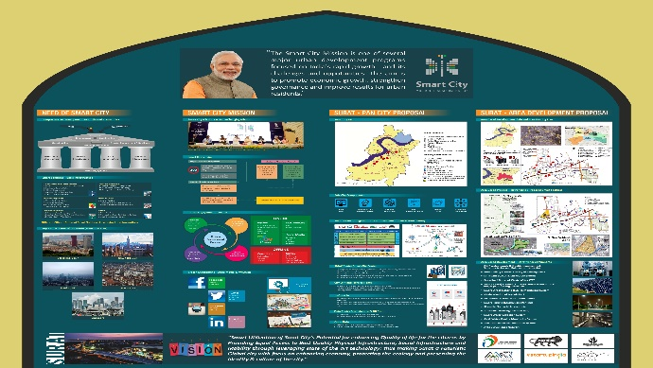
13. Urban Renewal and Public Recreation Projects
SMC undertook several urban renewal projects to convert under-utilised and neglected spaces into vibrant public recreation areas. One notable example is the transformation of spaces beneath Shaheed Veer Bhagat Singh Bridge into community-friendly zones. These areas now include sports facilities, children’s play zones, seating areas, walking tracks, and open spaces for social interaction. The initiative improved urban aesthetics, encouraged physical activity, and created inclusive spaces accessible to people of all age groups.
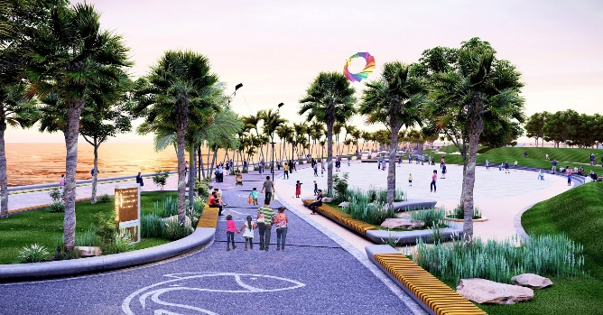

14. Enforcement Against Waste Mismanagement
To address issues of illegal dumping and improper waste disposal, Surat Municipal Corporation strengthened its enforcement mechanisms. Inquiry panels were formed to investigate violations, and stricter penalties were imposed on offenders. Monitoring systems were upgraded, and coordination between sanitation departments was improved to ensure accountability. These actions reinforced environmental protection laws and helped maintain cleanliness standards across industrial, commercial, and residential areas of the city.
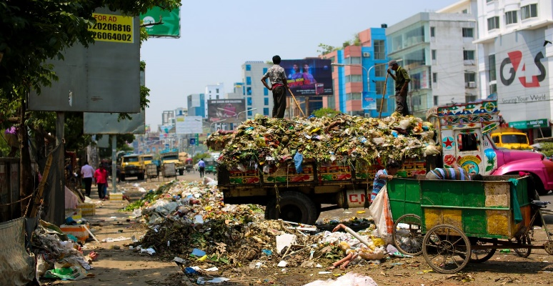
15. Virtual Civic Centre and e-Governance
Surat Municipal Corporation expanded its e-governance initiatives through the Virtual Civic Centre and mobile applications to make municipal services more accessible to citizens. Services such as property tax payments, water bill payments, birth and death certificates, trade licenses, and grievance redressal can now be accessed online. This digital transformation reduced paperwork, improved transparency, shortened service delivery time, and increased citizen participation. The initiative represents a significant step towards smart and citizen-centric urban governance.
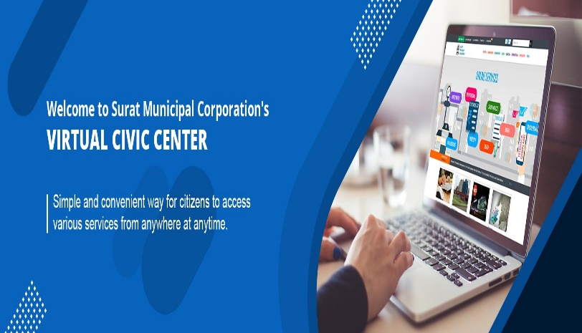
sss